Roll No: 24280066
Name: Khuram Rashid
Annexure: music_producer.py file with generating 'skip' events
Screenshot of Download, Skip and Play Events

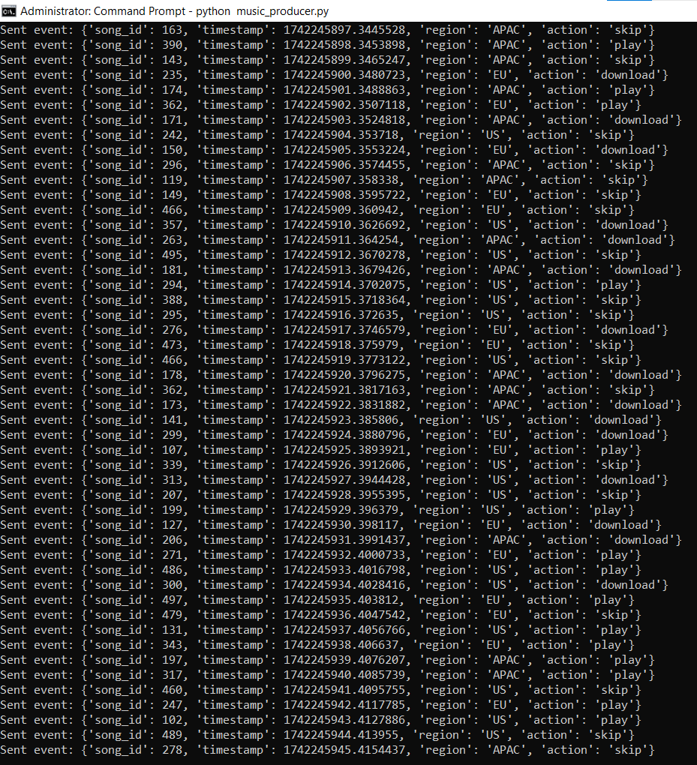

Error on the pyspark command
